A Secured Watermarking Algorithm for Medical Image

A PROJECT REPORT

Submitted in partial fulfillment for the award of the degree of

M.S

in

Software Engineering

By

KARUNAKARAN.G
(12MSE0122)

Under the guidance of

Prof. R. Srinivasa Perumal
Assistant Professor (Selection Grade)



School of Information Technology and Engineering
May, 2017

DECLARATION BY THE CANDIDATE

I hereby declare that the project report entitled “A Secured Watermarking Algorithm for Medical Image” submitted by me to VIT University, Vellore in partial fulfillment of the requirement for the award of the degree of MS (Software Engineering) is a record of bonafide project work carried out by me under the guidance of Prof.R.SrinivasaPerumal. I further declare that the work reported in this project has not been submitted and will not be submitted, either in part or in full, for the award of any other degree or diploma in this institute or any other institute or university.

Place: Vellore Signature of the Candidate

Date: KARUNAKARAN.G

School of Information Technology & Engineering [SITE]

CERTIFICATE
This is to certify that the project report entitled “A Secured Watermarking Algorithm for Medical Image” submitted by KARUNAKARAN.G (12MSE0122) to VIT University, Vellore, in partial fulfillment of the requirement for the award of the degree of M.S in Software Engineering is a record of bonafide work carried out by him/her under my guidance. The project fulfills the requirements as per the regulations of this Institute and in my opinion meets the necessary standards for submission. The contents of this report have not been submitted and will not be submitted either in part or in full, for the award of any other degree or diploma and the same is certified.

Prof. R. Srinivasa Perumal, Assistant Professor Dr. Valarmathi. B
INTERNAL GUIDE Head of Department
Department of Software and
Systems Engineering

The project work is satisfactory / unsatisfactory

Internal Examiner External Examiner

Acknowledgement

I wish to express our heartfelt gratitude to Dr.G.Viswanathan, Chancellor, VIT University,Vellore for providing facilities for the Final year project.
I am highly grateful to our Vice Presidents, Shri. Sankar Viswanathan, Dr. Sekar Viswanathan and Shri. G.V.Selvam, Vice Chancellor Dr. Anand A. Samuel, Pro-Vice Chancellors Dr. S. Narayanan and Dr. V. Raju for providing necessary resources.
My sincere gratitude to Dr. Aswani Kumar Cherukuri, Dean, School of Information Technology and Engineering for giving us the opportunity to undertake the project.
I wish to express my sincere gratitude to Dr. Valarmathi. B, Associate Professor, HOD of Software and Systems Engineering and the Project Coordinator Prof. Manivannan S, Assistant Professor (SG) ,School of Information Technology and Engineering for providing me an opportunity to do my project work in industry/VIT University.
I would like to express my special gratitude and thanks to my internal guide Prof. R. Srinivasa Perumal ,Assistant Professor (Selection Grade), School of Information Technology and Engineering whose esteemed guidance and immense support encouraged to complete the project successfully.
I thank the Management of VIT University for permitting me to use the library resources. I also thank all the faculty members of VIT University for giving me the courage and strength I needed to complete my goals. This acknowledgement would be incomplete without expressing my whole hearted thanks to my family and friends who motivated me during the course of the work.

Place : Vellore Signature of the student
Date : KARUNAKARAN.G
Table of Contents

Chapter No | Title | Page No
 | ABSTRACT | I
 | LIST OF FIGURES | II
 | LIST OF TABLES & LIST OF ACRONYMS | III
1. | INTRODUCTION
 | 1.1 Background | 1
 | 1.2 Problem Statement | 1
 | 1.3 Motivation | 2
 | 1.4 Related work | 2
 | 1.5 Challenges | 4
 | 1.6 Essence of Approach | 4
 | 1.7 Assumptions | 5
 | 1.8 Organization of Report | 5
 | 1.9 Drawback of Existing system | 5
 | 1.10 Aims and Objectives | 5
2. | OVERVIEW / LITERATURE REVIEW
 | 2.1 System Overview | 6
 | 2.2 Literature Review | 8
3. | SYSTEM DESIGN
 | 3.1 System Architecture | 11
4 | IMPLEMENTATION & TESTING
 | 4.1 Implementation Strategy-Modular Description | 15
 | 4.2 Algorithm Implementation | 18
 | 4.3 Tools, Techniques and Methodology | 20
 | 4.4 Testing Methods
 | 4.4.1 Unit Test case Specification | 20
 | 4.4.2 Integration Test case Specification | 24
 | 4.4.3 System Test case Specification | 27
5 | RESULTS & DISCUSSIONS
 | 5.1 Results | 28
 | 5.2 Screenshots | 29
6 | CONCLUSION & FUTURE WORK
 | 6.1 Conclusion | 31
 | 6.2 Future Work | 31
7 | CODING | 32
8 | REFERENCES | 36

ABSTRACT

Digital watermarking technique has been dramatically used in telemedicine .Nowadays medical images are transmitted through network that want security for various application. The two schemes of image watermarking are categorized into spatial domain and frequency domain respectively. The system scope is robust secure and lossless digital watermarking on medical images so the method adaptable is frequency domain. In existing system, they develop watermarking algorithm based on ICA and DWT combined approach and insertion of two independent watermarks into medical images. In proposed method system developed an algorithm based on PCA, DWT and DCT combined approach for embedding three medical images into video frame. The following steps are involved in proposed method. First, Get an image from video frame and compute a scale value. Second use PCA to divide the image into three segment. Third apply DWT and resultant be LL, LH, HL, HH. Fourth scale values get multiplied with three medical images and these three images get add up with segmented part in HH band. And finally inversion of DWT and PCA to obtain original image and it is added to its original frame. Many performance factors are considered to evaluate the performance parameter of the proposed scheme. The performance evolution factors include MSE and PSNR better than existing methods. This medical image watermarking technique can avoid unnecessary modification by unauthorized person.

LIST OF FIGURES

S.NO | Figure Name | Page No
1 | Fig 3.1 System Architecture | 11
2 | Fig 3.1.1 Embedding process | 11
3 | Fig 3.1.2 Extraction process | 12
4 | Fig 3.2.1 DFD level 0 | 13
5 | Fig 3.2.2 DFD level 1 | 13
6 | Fig 3.2.3 DFD level 2 | 14
7 | Fig 4.2.1 Discrete wavelet transform | 19
8 | Fig 5.2.1 Main page | 29
9 | Fig 5.2.2 Embedding page | 29
10 | Fig 5.2.3 Extraction page | 30

LIST OF TABLES

S.NO | Table Name |  | Page No
1 | TABLE 4.1 UTC001 |  | 20
2 | TABLE 4.2 ITC001 |  | 24
3 |  | TABLE 4.3 STC001 |  | 27
4 |  | Result Table |  | 28

LIST OF ACRONYMS

PCA: Principle Component Analysis
DWT: Discrete Wavelet Transform
DCT: Discrete Cosine Transform
OS: Operating System
MSE: Mean Squared Error
PSNR: Peak signal-to-noise ratio

MATLAB: Matrix Laboratory

CHAPTER-1

INTRODUCTION

1.1 BACKGROUND

In recent years, Digitalization of information has been a method to handle data and these get transmitted through network that leads to availability of data in the public. Telemedicine is the field which provides health care through electronic information technologies when patient are far from the doctor. Most hospitals and health care centers have huge patient data that are transmitted through a medium internet with a mask images and most of patient data like patient details, patient medical images (X-ray, CT Scan, MRI) and some disease report. Personal information need privacy and these should be protected. Basic idea of digital watermarking is to embed a watermark into original frame and after extraction it must be similar to original image so that doctor provide proper treatment.

1.2 PROBLEM STATEMENT

To overcome the difficulty of change in medical reports and unwanted personal presence by the traditional methods the recent information and communication technologies were introduced. Three important characteristics are mandatory to be imposed in security of medical images are reliability, availability, confidentiality. The ability of an extracted image to be used for an authentication process in normal conditions of access is availability. Confidentiality is to be kept secret to unknown person. Reliability has two aspects one is authentication which authenticates that the correct patient gets accessed on an image other one with integrity which protects the images modified by an unauthorized. Security risks during transmission of medical images random error on images can occur in network during exchanges within and to other hospital network.

1.3 MOTIVATION

In this system, our goal is to design a security scheme to protect patient information while making the information readily accessible when necessary. The design of our project was motivated by the following points: Nowadays, the patient information is usually printed in the corner of the medical images for viewing. Thus, it is easily accessible to everybody. Unknown person can easily know the confidential details without any effort. The patient information prominently displayed may be intercepted by a third party during electronic transmission. Sometimes, this could cause a big lawsuit. If confidentiality leaks then there is a loop hole for organ trading system. Organ trade is the trade of human organs, tissues or other body parts for the purpose of transplantation. There is a global need or demand for healthy body parts for transplantation, far exceeding the numbers available. Matching and compatibility are need before transplanting any organ. To overcome these without presence of patient the medical images and patient details can’t be extracted from the watermark.

1.4 RELATED WORK

Amit Mehto, Neelesh Mehra [1], proposed a lossless embedding watermarking algorithm which uses the combined DWT-DCT algorithm embedded watermarks in original medical image. It embeds watermark like patient’s name, disease’s name, hospital’s name, and doctor’s signature into original medical image.
Watermarking embedding process is carried out by apply DWT to decompose the original image into four non-overlapping multi resolutions sub-band (LL, LH, HL and HH). After the decomposition of high frequency sub-band HH, apply DCT. After that find adaptive scaling factor. Embeds the watermark in the DCT of HH. Apply the IDCT and IDWT and construct the watermarked image.
Watermarking extraction process is followed by apply DWT to decompose original image and watermarked image into the four multi-resolution sub-bands (LL, LH, HL and HH).After the decomposition of high frequency sub-band HH, apply DCT in both image. After that find adaptive scaling factor. Extracted the watermark using subtraction of DCT values of both image HH sub-band, and multiplied with the adaptive scaling factor to DCT value of coefficient.
S.Siva Kannan, G.Thirugnanam, C.Sheeba Joice (2016) [2], developed watermarking algorithm based on ICA and DWT combined approach and insertion of two independent watermark into medical image (RONI). They separated region of interest (ROI) from medical image and from RONI image they separated that into N/2 X M/2 observation images. And then they applied ICA to all the observation images. Then choose the two components from high frequency level. Selected sub band is wavelet transformed. The two independent watermark image is embedded into the corresponding position. Make the whole image Inverse DWT and Inverse ICA transformed and get the cover image and watermark. Here patient fingerprint and patient data template taken as watermark. And combine the components and ROI to RONI and the resultant component was watermarked image. To extract watermark follow the same procedure extract and compare.

C.Thirumarai Selvi, R.Sudhakar, G.Priyadharshini [3], proposed a DWT based watermarking approach for medical image authentication. In the method DWT is applied resultant are four sub bands. Then the LL component is separated and it divided into 3x3 non overlapping blocks. Here the LL components is chosen to embed the watermark content. In each block the center pixel is considered as threshold bi and the pixels around it are compared with gray difference between center pixel and the bi is given with binary values 0 or 1. All the applied values bi are applied with XOR function and it is assigned to a separate variable. Then the pixel values of watermarked content XORed with the previous XOR result. The watermark bits embedded into low frequency component of the host image blocks one after the other. The above step are repeated until all the bits of watermark content are embedded into low frequency component of host image. Finally the watermarked image is now obtained by taking inverse DWT. Now extraction is same procedure as followed for embed.

Anushikha Singh,Namrata Raghuvanshi,Malay Kishore Dutta [4], proposed An SVD Based Zero Watermarking Scheme for Authentication of Medical Images for Tele-medicine Applications. The proposed framework of medical image integrity verification is broadly divided into two parts: A. Creation of Secret Share. B. Recovery of Patient ID for Image Verification. Read input fundus image and divide it into non overlapping blocks of size 4x4. Then apply SVD to each block. From SVD collect Singular values array and take median of it. Least Significant bit of M is considered as a binary bit for each block to generate Master Share (Ms) for the input image. Get the digital patient ID for the input image and encrypt it using Arnold cat map. Apply logical XOR operation to encrypted patient ID and Master share. To recover process read input fundus image. Create Master Share (Ms) for the input image. If authorized access of Secret Share then logical XOR for secret share and Master Share and decrypt it using Arnold cat map algorithm and verify the image.

1.5 CHALLENGES
The challenges faced on watermarking as follows:
1. Fidelity: The changes entailed by marking should not affect the value of the content, and ideally the mark should be imperceptible. Specifically, experts in the medium should not be able to discriminate between the watermarked data and the original.
2. Robustness: Watermarks should survive standard data processing, such as would occur in a creation and distribution process.
3. Security: Watermarks should survive deliberate attempts to remove them. Ideally, a watermark should remain readable up to the point where the content becomes modified enough to be of low value. A potential attacker can try standard processing techniques, but can also try less natural transformations specifically designed to erase watermarks.

1.6 ESSENCE OF APPROACH

Retrieving a data after embedded without a loss is a challenging problem in digital watermarking. To overcome strategy preprocessing methods are used after extraction. And choosing a cover image has a sense to be double the size of watermark since algorithm used divided the cover image to half the size of it. These tend to be sub frequency band to embed a watermark. It’s up to your choice to separate the component from cover image. So these methods are formally approached. Experiments have proved this method will provide better results.

1.7 ASSUMPTIONS
In these system while extraction there was a problem with random error on images each pixel have some lower and higher values from the actual content and some values in watermark get dumped to output image these was because high intensity values remain same. To overcome that strategy we used some preprocessing steps and these give some promising result.

1.8 ORGANIZATION OF REPORT
The report is organized in the following way. What follows is the literature review of the previous works. Then, the design and setup of the system is explained. The details about implementation of the proposed a secured watermarking algorithm for medical images are explained in the section after design. The results and discussion of the future works, and the conclusions drawn are all explained in the further sections.

  - DRAWBACK OF EXISTING SYSTEM
The following drawbacks are:
- They use formal method of watermarking technique these method gives low robustness and they embed patient data on medical images which was not promising.
- The methods are very usual and these are frequently used approach in a watermarking and these been extracted easily.
- There are no reliability content over the watermarking technique to safe the data from unknown person.
1.10 AIMS AND OBJECTIVES
The main aim is to augment the privacy and security in medical image usually one or two images get embedded in to cover image and these get persistent to various attack. Here the system has three images to embed and these too gives promising result.
The main aim is to propose a secured watermarking on medical image system has concern on patient privacy and also security while transferring data or to view a data.

CHAPTER-2

2.1 SYSTEM OVERVIEW

2.1.1 PROPOSED SYSTEM
In the proposed system, choose an image frame from video and check whether it’s double the size of watermark image. In these method a cover image of size 512x512x3 as three dimensional matrix and patient information are medical image, finger print, and report these have size of 256x256 as two dimensional matrix. Next process is embedding these patient information into cover image. Firstly, apply Discrete Cosine Transform in cover image and get scale value of that image. Then apply Principle Component Analysis in cover image these resultant are separated into three component images. After component separation apply Discrete Wavelet Transform to each individual component of separated image. The outputted has four frequency sub-band (LL, LH, HL, and HH). In these add up patient information details to each individual component of HH band. Before these step multiply the scale value to patient information content. After that apply Inverse Discrete Wavelet Transform to that frequency sub band. These get clubbed now apply Inverse PCA and resultant cover image of size 512x512x3. Now add these image frame to video. Extraction process is more similar as embedding process only difference is subtracting the separated component and apply Discrete Wavelet Transform resultant of HH band has watermark image.

ADVANTAGES
- To overcome the difficulty of change in medical reports and unwanted personal presence fingerprint authentication methods were introduced.
- Principle Component Analysis gives stability to embed three watermark in cover image.
- Discrete Cosine Transform provides a secret scale value which gives robustness.
- Finally it’s a security scheme to protect patient information while making the information readily accessible when necessary.
2.1.2 SYSTEM REQUIREMENTS
HARDWARE REQUIREMENTS:
- System : Dual Core 2.4 GHz.
- Hard Disk : 80 GB.
- Monitor : 15 VGA Colour.
- Ram : 1GB.
SOFTWARE REQUIREMENTS:
- Operating System : Windows 10 Home.
- Technology : Image Processing
- IDE : MATLAB
- MATLAB Version : MATLAB R2013a
.

2.1.3 SYSTEM ANALYSIS & USER REQUIREMENTS
The proposed system is analyzed depending on the user requirements and a feasibility study is done based on the given requirements and it has been found that the system is feasible to be developed.
The user requirements are as follows.
The system is required to be reliable and confidentiality is key feature of our system to protect patient details and robust enough against attacks.

2.2 LITERATURE REVIEW

Amit Mehto, Neelesh Mehra (2016) [1], proposed an Adaptive lossless embedding watermarking algorithm which uses the combined DWT-DCT algorithm embedded watermarks in original medical image. Watermarking embedding process is carried out by apply DWT to decompose the original image into four non-overlapping multi resolutions sub-band (LL, LH, HL and HH). After the decomposition of high frequency sub-band HH, apply DCT. After that find adaptive scaling factor. Embeds the watermark in the DCT of HH. Apply the IDCT and IDWT and construct the watermarked image. The result of watermarked image and recovered watermark with different embedding factor 0.5 x alpha, alpha and 2 x alpha. When using embedding factor 0.5 x alpha recovered watermark is distorted and information not proper visible but when using embedding factor alpha quality of recovered watermark increases and information of watermark proper visible than 2 x alpha. So here values of embedding factor alpha is good for watermarking process and provide better result.

Advantage:
- Here computing embedding factor of alpha is good trade so that easy to adjust factor if output is distorted these increase the quality of recovered watermark.
- Here scale value are not predefined process it’s actually computation process which gives additional advantage to the system.
Disadvantage:
- Here embedding patient information to patient medical image will give some distortion to original image that may cause of poor diagnosis.
- Here some preprocessing methods can be introduced to increase the promising result.

S.Siva Kannan, G.Thirugnanam, C.Sheeba Joice (2016) [2], developed watermarking algorithm based on ICA and DWT combined approach and insertion of two independent watermark into medical image (RONI). They separated region of interest (ROI) from medical image and from RONI image they separated that into observation images. And then they applied ICA to all the observation images. Then choose the two components from high frequency level. Selected sub band is wavelet transformed. The two independent watermark image is embedded into the corresponding position. Make the whole image Inverse DWT and Inverse ICA transformed and get the cover image and watermark. By applying this algorithm the experimental results have demonstrated that the proposed algorithm is imperceptible because the average PSNR values are around 45.5 dB. Moreover, the proposed watermarking system is most robust, because it can keep the image quality well.
Advantage:
- Here component separation gives more advantage to embed a watermark of any size applicable.
- Separation ROI region is good approach when there is slight change in ROI that leads to improper diagnosis.
Disadvantage:
- Here embedding patient information to patient medical image will give some distortion but over using ROI is actually common approach.
- Here 2 level DWT approach can be avoided these may reduce the image quality.

C.Thirumarai Selvi, R.Sudhakar, G.Priyadharshini [3], proposed a DWT based watermarking approach for medical image authentication. In the method DWT is applied resultant are four sub bands. Then the LL component is separated and it divided into 3x3 non overlapping blocks. Here the LL components is chosen to embed the watermark content. In each block the centre pixel is considered as threshold bi and the pixels around it are compared with gray difference between centre pixel and the bi is given with binary values 0 or 1. All the applied values bi are applied with XOR function and it is assigned to a separate variable. Then the pixel values of watermarked content XORed with the previous XOR result. The watermark bits embedded into low frequency component of the host image blocks one after the other. The proposed method is examined by the performance metrics MSE and PSNR. When we use higher level DWT methods for watermarking it is expected to give the result with lesser execution time when compared to this method. The average PSNR values are around 45.95 dB.

Advantage:
- It’s a critical point of handling data with 3x3 block of comparing its pixel and providing its bi values. Here security is added up to the system.
- It gives confidentiality to the watermark image.
Disadvantage:
- Using single watermark image will not give proper usage of process.
- It fails at reliability of authentication.

Anushikha Singh,Namrata Raghuvanshi,Malay Kishore Dutta [4], proposed An SVD Based Zero Watermarking Scheme for Authentication of Medical Images for Tele-medicine Applications. The proposed framework of medical image integrity verification is broadly divided into two parts: A. Creation of Secret Share. B. Recovery of Patient ID for Image Verification. Read input fundus image and divide it into non overlapping blocks of size 4x4. Then apply SVD to each block. From SVD collect Singular values array and take median of it. Least Significant bit of M is considered as a binary bit for each block to generate Master Share (Ms) for the input image. Get the digital patient ID for the input image and encrypt it using Arnold cat map. Apply logical XOR operation to encrypted patient ID and Master share. To recover process read input fundus image. Create Master Share (Ms) for the input image. The proposed work develop a SVD based zero watermarking scheme to solve this issue. Experimental results indicate that created secret share is completely non informative ensuring the security of medical image and patient ID.
Advantage:
- Here creating a secret share by using XOR function with patient ID and master share increase the security and confidentiality.
- Recovering watermark is highly unsustainable for attackers.
Disadvantage:
- There are no reliability content over the watermarking technique to safe the data from unknown person.
- Fidelity of the original cover image may get affected to it.

CHAPTER-3

DESIGN

3.1 SYSTEM ARCHITECTURE

3.1.1 Embedding process

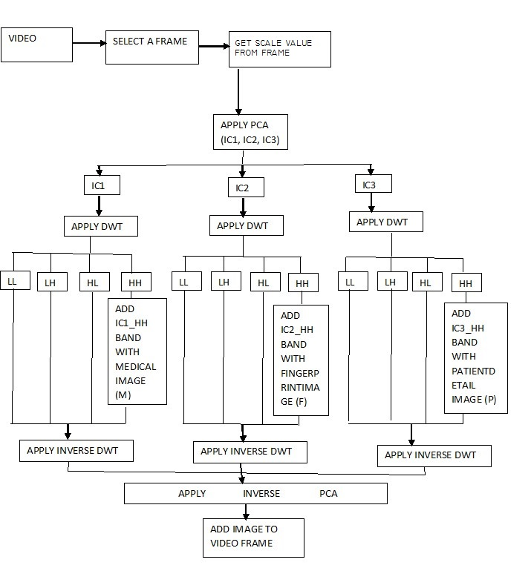

3.1.2 Extraction process

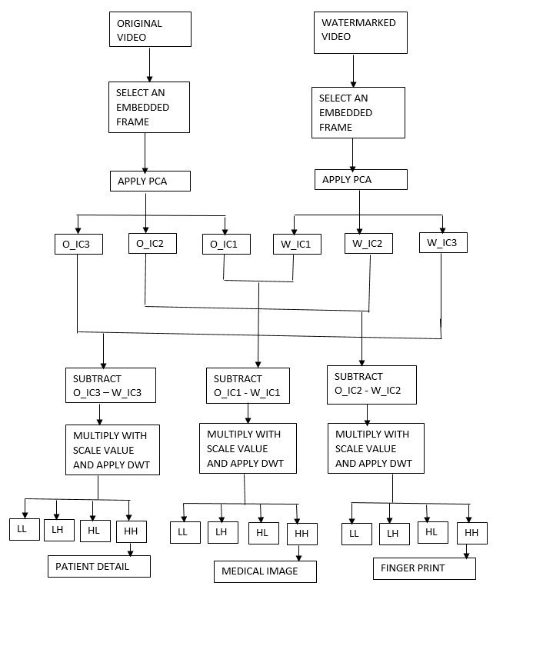

Fig-3.1 System Architecture

3.2 DATAFLOW DIAGRAM

3.2.1 DFD level 0:

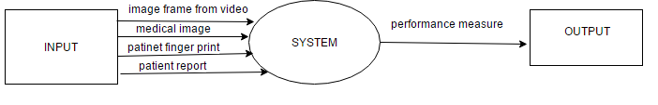
Fig-3.2.1 DFD level 0.

3.2.2 DFD level 1:

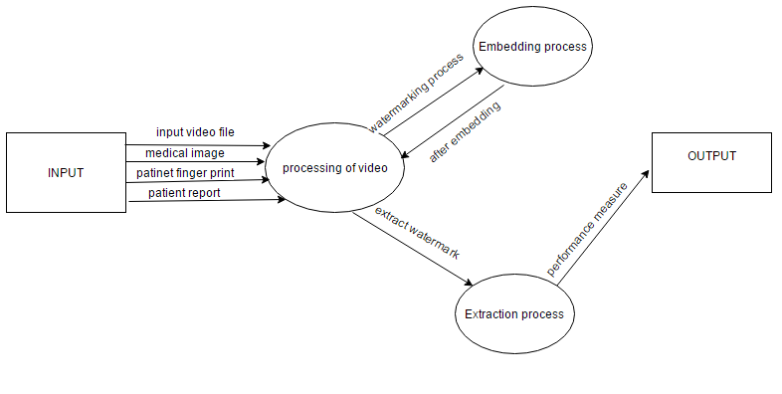
Fig-3.2.2 DFD level 1

3.2.3 DFD level 2:

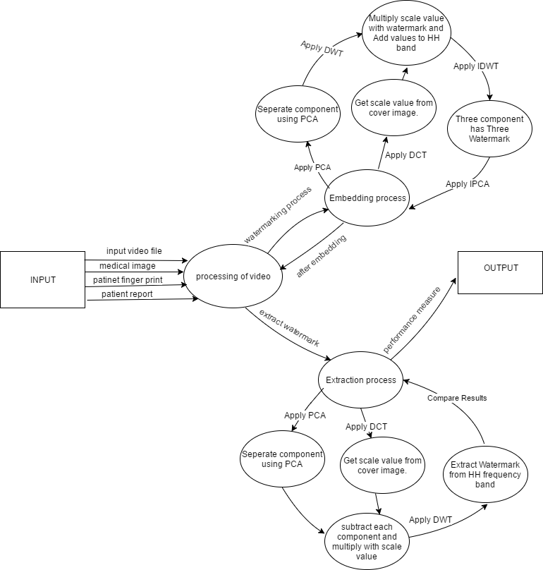

Fig-3.2.3 DFD level 2.

CHAPTER-4

IMPLEMENTATION AND TESTING

4.1 IMPLEMENTATION strategy
MODULAR DESCRIPTION

Implementation is the stage of the project when the theoretical design is turned out into a working system. Thus it can be considered to be the most critical stage in achieving a successful new system and in giving the user, confidence that the new system will work and be effective. The implementation stage involves careful planning, investigation of the existing system and it’s constraints on implementation, designing of methods to achieve changeover and evaluation of changeover methods.

MODULES

- Embedding process
  - Video Embedded Frame image
  - Embedded function
  - Scale function
- Extraction process
  - Video Extraction Frame image
  - Extraction function
  - Error function

MODULES DESCRIPTION:

4.1.1 Embedding process

Video Embedded Frame image:

In our system, video file is a content region to embed a watermark for which the method need an image as an input. So system select a frame from a video and separate it from the video file. To select a frame may be random selection or hash based selection from patient id are the two methods are permissible. Most likely hash based selection from patient id gives good frame selection. The frame image extracted is input to embedding method.

Embedded function:

In these method, frame image is input and three other watermarking are combined so four images are given as input to these function. Frame image is considered as cover image. Scale value get computed using scale function. And these scale value get multiplied with watermarking image. After that Principle component analysis is applied over cover image and image get separated into individual components. These individual components are then inputted to Discrete Wavelet Transform and frequency sub-bands are outputted. Multiplied scale value watermark image get add up with HH frequency band. Inverse DWT and Inverse PCA are applied and embed to same frame in a video file.

Scale function:

In these method, scale value get computed from cover image it’s a secret value which was not predefined but the process to compute was actually input cover image was converted to gray scale. Then 8x8 block was separated and DCT was applied to it. These process continues till last 8x8 block. All these values get arrayed up and take mean and resultant be a single value.

4.1.2 Extraction process

Video Extraction Frame image:

In these method, embedded frame image should be selected and extract the content from that file is the actual process. So the system need an image from watermarked video as well as from original image. From that select two image frame which has actual content. To select a frame may be random selection or hash based selection from patient id are the two methods are permissible. Most likely hash based selection from patient id gives good frame selection. Follow the method which was used previously for embedding. The frame image extracted is input to extraction method.

Extraction function:

In these method, two frame image was selected and these must have the actual content. To extract firstly apply scale function to original frame image and get a secret value. Apply PCA to both frame image and separate the component. Subtract the components of watermark frame image and original frame image. And apply DWT to each output and these HH frequency band have the actual content of watermark image.

Error function:

In these method we compare the original image and watermark image difference using MSE and PSNR. Here MSE value should be as low as possible and PSNR value must be as high as possible to make accuracy. These values are outputted to the main GUI for easy notification of error checking.

4.2 ALGORITHM IMPLEMENTATION

Principle Component Analysis:

The basic operation of PCA as follows:
1. Standardize the data.
2. Obtain the Eigenvectors and Eigenvalues from the covariance matrix or correlation matrix, or perform Singular Vector Decomposition.
3. Sort eigenvalues in descending order and choose the k eigenvectors that correspond to the k largest eigenvalues where k is the number of dimensions of the new feature subspace (k ≤ d).
- Construct the projection matrix W from the selected k eigenvectors.
- Transform the original dataset X via W to obtain a k-dimensional feature subspace Y.

Discrete Cosine Transform:

The basic operation of the DCT is as follows:
1. The input image is N by M.
2. f (i, j) is the intensity of the pixel in row i and column j.
3. F (u, v) is the DCT coefficient in row k1 and column k2 of the DCT matrix.
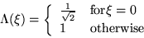
4. For most images, much of the signal energy lies at low frequencies these appear in the upper left corner of the DCT.
5. Compression is achieved since the lower right values represent higher frequencies, and are often small - small enough to be neglected with little visible distortion.
6. The DCT input is an 8 by 8 array of integers. This array contains each pixel's gray scale level.
7. Eight bit pixels have levels from 0 to 255.

Discrete Wavelet Transform:

First, we apply a one-level, one dimensional DWT along the rows of the image. Second, we apply a one-level, one-dimensional DWT along the columns of the transformed image from the first step and the result of these two sets of operations is a transformed image with four distinct bands: (1) LL, (2) LH, (3) HL and (4) HH. Here, L stands for low-pass filtering, and H stands for high-pass filtering. The LL band corresponds roughly to a down-sampled (by a factor of two) version of the original image. The LH band tends to preserve localized horizontal features, while the HL band tends to preserve localized vertical features in the original image. Finally, the HH band tends to isolate localized high-frequency point features in the image. As in the one-dimensional case, we do not necessarily want to stop there, since the one-level, two-dimensional DWT extracts only the highest frequencies in the image. Additional levels of decomposition can extract lower frequency features in the image these additional levels are applied only to the LL band of the transformed image at the previous level. Here is the three-level, two-dimensional DWT on a sample image.
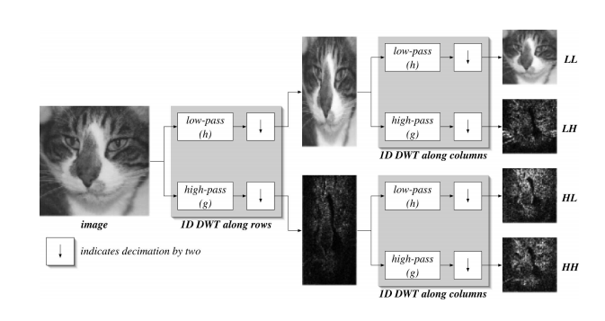

Fig 4.2.1 discrete wavelet transform
4.3 TOOLS, TECHNIQUES AND METHODOLOGY
The developer should do the static verification such as inspecting the work product, and dynamic verification such as software testing. The developer should observe the operational behavior of the system when it’s executed with the test data.
4.3.1 Tools used
To develop this system, matlab is most commonly used platform for image processing. The graphical output is optimized for interaction. You can plot your data very easily, and then change colors, sizes, scales by using the graphical interactive tools. Statistics Toolbox allows more specialized statistical manipulation of data.

4.4 TESTING METHODS

4.4.1 UNIT Test Case Specification

Black Box Testing
UTC-B-001
Test Case ID | UTC-B-001
Test Case Description | To pass the file path to our system
Expected Output | File path is correctly given to our system
Test Procedure
Step | Input | Expected Output
1. | Input Dataset | File path is to be mentioned correctly.

Table 4.1 UTC-B-001

WHITE BOX TESTING

UTC-W-001
Test Case ID | UTC-W-001
Test Case Description | Cover image Matrix dimension must be double the watermark image
Expected Output | Cover image was double size of watermark image
Test Procedure
Step | Input | Expected Output
1. | Size of image | Cover image was double size of watermark image

Table 4.1 UTC-W-001

UTC-W-002
Test Case ID | UTC-W-002
Test Case Description | To apply PCA matrix values of data type should be double.
Expected Output | Matrix values are in double to apply PCA.
Test Procedure
Step | Input | Expected Output
1. | Watermark Image and original image | Matrix values are in double

Table 4.1 UTC-W-002

UTC-W-003
Test Case ID | UTC-W-003
Test Case Description | Reshape after component separation to 3 dimensional matrix.
Expected Output | Reshape of three dimensional matrix to image
Test Procedure
Step | Input | Expected Output
1. | Matrix as image. | Reshape of three dimensional matrix to image

Table 4.1 UTC-W003
UTC-W-004
Test Case ID | UTC-W-004
Test Case Description | Convert double data type to unit8 values as image.
Expected Output | Converted from double to uint8.
Test Procedure
Step | Input | Expected Output
1. | Image matrix values | Converted from double to uint8.

Table 4.1 UTC-W-004
UTC-W-005
Test Case ID | UTC-W-005
Test Case Description | Select exact frame image from video file.
Expected Output | Frame image that get embed must be selected.
Test Procedure
Step | Input | Expected Output
1. | Video file | Frame image that get embed must be selected.

Table 4.1 UTC-W-005
UTC-W-006
Test Case ID | UTC-W-006
Test Case Description | In scale function the cover image should be converted to gray scale.
Expected Output | Cover image converted to gray scale.
Test Procedure
Step | Input | Expected Output
1. | Scale function | Cover image converted to gray scale.

Table 4.1 UTC-W-006

4.4.2 INTEGRATION TEST CASE SPECIFICATION

ITC001 – Test the link between GUI to function.

Test Case ID | ITC001
Test Case Description | Check the interface link between GUI to main function.
Expected Output | Pass the file path from GUI to algorithm.
Test Procedure
Step | Input | Expected Output
1. | Link between GUI to another function | Pass the file path from GUI to algorithm.

Table 4.2 ITC001

ITC002 – Test whether link established between main and embedded function.
Test Case ID | ITC002
Test Case Description | Check the interface link between main and embedded function.
Expected Output | Three watermark images and a cover image are input to embedded function.
Test Procedure
Step | Input | Expected Output
1. | Link between main function to embedded function is to be checked | Three watermark images and a cover image are input to embedded function.

Table 4.2 ITC002

ITC003 – Test whether the link is established between GUI to extraction function.

Test Case ID | ITC003
Test Case Descriptio | Check the interface link between GUI to extraction function.
Expected Output | Original video link and watermark video link are passed as parameter.
Test Procedure
Step | Input | Expected Output
1. | Link GUI to extraction function is to be ensured properly | Original video link and watermark video link are passed as parameter.

Table 4.2 ITC003

4.4.3 SYSTEM TESTING

STC001 – Test whether the classifier performs as expected.
Test Case ID | STC001
Test Case Description | Check the watermarking algorithm works as expected.
Expected Output | Extraction content works fine with minimum error rate.
Test Procedure
Step | Input | Expected Output
1. | Secured watermarking algorithm. | Extraction content works fine with minimum error rate.

Table 4.3 STC001

CHAPTER 5

RESULTS AND DISCUSSION
5.1 Results
The proposed algorithm of a secured watermarking algorithm for medical image is provided lossless medical image watermarking procedure with embedding and extraction of the watermark which is basically patient information. The experimental results indicate the efficiency of the proposed scheme. The value of PSNR represent that the image quality is not degraded and provide good visualization the value of PSNR for proposed work of watermark image with original image is 40 to 45 dB which is high enough to visualized the image data and it show that propose algorithm provide imperceptibility and security of patient information.

Results Table:

Methods | MSE Values | PSNR Values
DCT and DWT Technique [1]. | Patient details:2.73 | Patient details:43.76
ICA and DWT combined  Approach [2]. | Finger print: 2.04  Patient Detail: 1.32 | Finger print: 45.03  Patient Detail: 46.92
PCA, DWT and DCT Algorithm (proposed system). | Medical data: 1.965  Finger print: 1.035  Patient Detail:0.00 | Medical data:45.128  Finger print: 47.983  Patient Detail: Inf

  - SCREENSHOTS
Main GUI
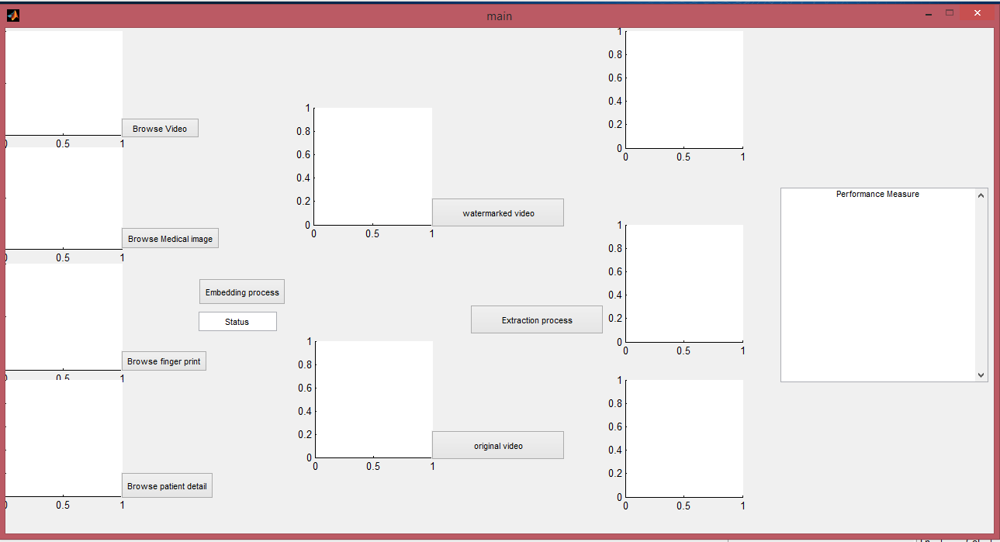
Fig 5.2.1 Main page

Embedded process
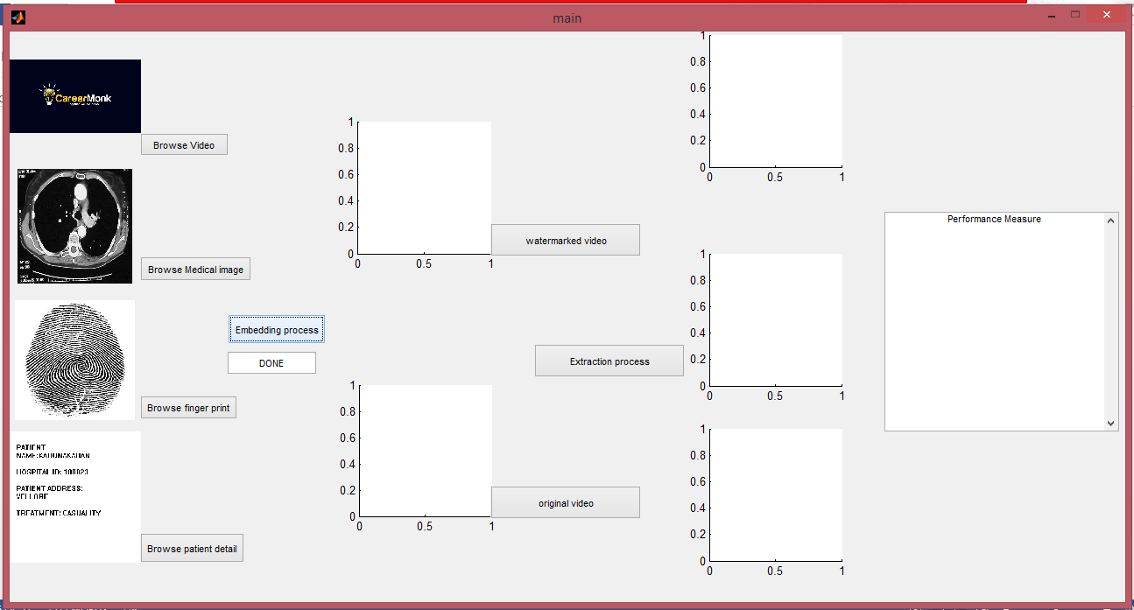
Fig 5.2.2 Embedding process
Extraction Process
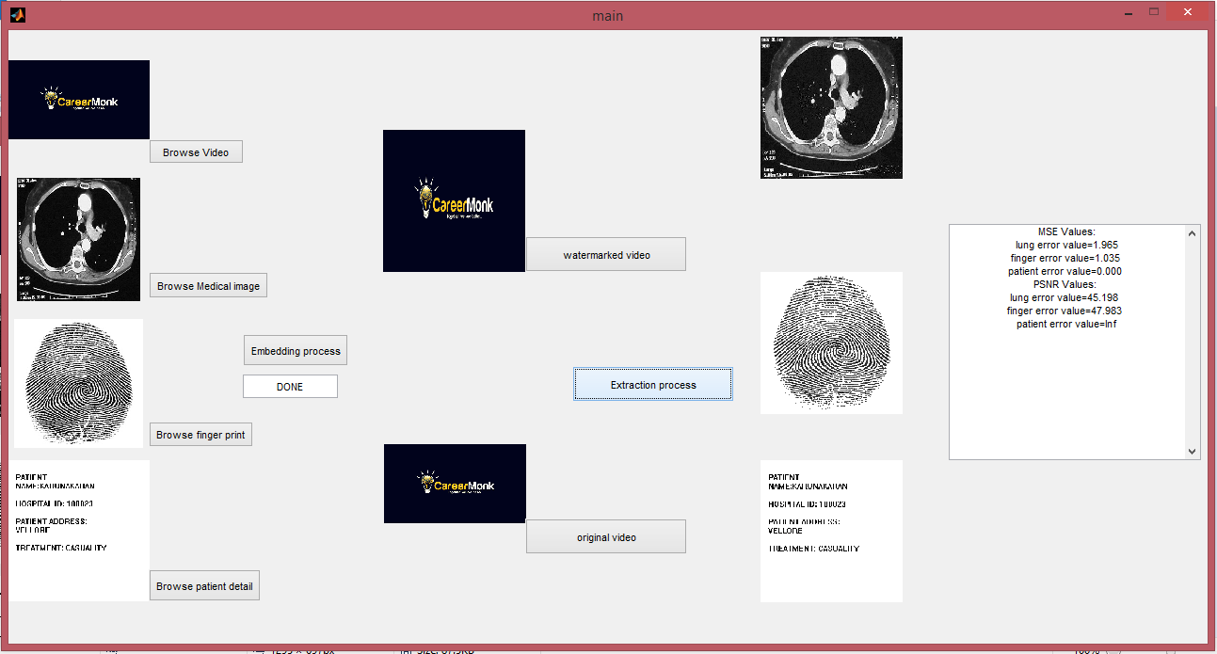
Fig 5.2.3 Extraction process

CHAPTER 6

CONCLUSION AND FUTURE WORK

6.1 CONCLUSIONS

I proposed a secured watermarking algorithm for medical images these applied as a security scheme to protect patient information while making the information readily accessible when necessary. To overcome the difficulty of change in medical reports and unwanted personal presence by the traditional methods get introduced. Our experimental study proves that our algorithm offers significant improvements over current approaches to privacy.

6.2 FUTURE WORK

In this system, we proposed an algorithm for embedding and extracting from a cover image in a video file. This method average MSE values are less than 1.9 and PSNR vales are around 45.5 dB. This system has complex method like seperating the components with actual size and again inversing the component after embed. So, in every method we suppose to monitor that image pixel value difference a slight difference will impact a lot in output image. This architecture has very complex structure of separating the modules. In future, to reduce error rate of the system, we will use some Optimization technique of preprocessing steps may reduce the error rate of the overall model.

CHAPTER-7
CODING

Frame_image.m
function [watermarked ] = frame_image( input_image,mmedi,ffingi,ppati )
peppers=input_image;
aimg=rgb2gray(imread(mmedi));
medical_image=im2double(aimg);
finger_print=im2double(rgb2gray(imread(ffingi)));
patient_detail=im2double(rgb2gray(imread(ppati)));
watermark=Embedded(peppers,medical_image,finger_print,patient_detail);
watermarked=watermark;
figure,imshow(watermarked);
end

Embedded.m
function [final] = Embedded( pepper,I,finger,patient )
scale_value=(scalefunction(pepper)/100);
[IC1,IC2,IC3,coeff,mu,score]=principal_ca(pepper);
[IC1_LL1,IC1_LH1,IC1_HL1,IC1_HH1]=dwt2(im2double(IC1),'haar');
[IC2_LL1,IC2_LH1,IC2_HL1,IC2_HH1]=dwt2(im2double(IC2),'haar');
[IC3_LL1,IC3_LH1,IC3_HL1,IC3_HH1]=dwt2(im2double(IC3),'haar');
medical=I*(scale_value/10);
fing=finger*(scale_value/10);
patie=patient*(scale_value/10);
medi=imresize(medical,[size(IC1_LL1,1) size(IC1_LL1,2)]);
finge=imresize(fing,[size(IC1_LL1,1) size(IC1_LL1,2)]);
pat=imresize(patie,[size(IC1_LL1,1) size(IC1_LL1,2)]);

medical_embedded=IC1_HH1+medi;
finger_embedded=IC2_HH1+finge;
patient_embedded=IC3_HH1+pat;
idwt1_result=idwt2(IC1_LL1,IC1_LH1,IC1_HL1,medical_embedded,'haar');
idwt2_result=idwt2(IC2_LL1,IC2_LH1,IC2_HL1,finger_embedded,'haar');
idwt3_result=idwt2(IC3_LL1,IC3_LH1,IC3_HL1,patient_embedded,'haar');
final_image=pca_reconstruction(idwt1_result,idwt2_result,idwt3_result,coeff,mu);
final_val=uint8(255 * mat2gray(final_image));
final=reshape(final_val,size(pepper,1),size(pepper,2),3);
end

Principle_ca.m
function [ Ipc1,Ipc2,Ipc3,coeff,mu,score ] = principal_ca( imag_e )
I = im2double(imag_e);
X = reshape(I,size(I,1)*size(I,2),3);
[coeff,score,latent,tsquared,explained,mu] = pca(X);
Itransformed = X*coeff;
Ipc1 = reshape(Itransformed(:,1),size(I,1),size(I,2));
Ipc2 = reshape(Itransformed(:,2),size(I,1),size(I,2));
Ipc3 = reshape(Itransformed(:,3),size(I,1),size(I,2));
end

Pca_reconstruction.m
function final_im= pca_reconstruction( I1,I2,I3,coef,mu)
ii1=I1(:);
ii2=I2(:);
ii3=I3(:);
emde=[ii1,ii2,ii3];
final_im=(double(emde)*transpose(coef))+mean(mu);
end

Scale_function.m
function mean_value = scalefunction( m_img )
data=rgb2gray(m_img);
fun = @(block_struct) dct2(block_struct.data);
B = blockproc(data,[8 8],fun);
vbr=uint8(255 * mat2gray(B));
val=vbr(1:8:end);
mean_value=mean(val);
end

Video_extract.m
function [II1,II2,II3] = video_extract( watermarked_video,original_video)
movieObj1=VideoReader(original_video);
movieObj2= VideoReader(watermarked_video); % open fil
get(movieObj1); % display all information about movie
get(movieObj2);
nFrames1 = movieObj1.NumberOfFrames;
nFrames2= movieObj2.NumberOfFrames;
if nFrames1==nFrames2
for iFrame=1:nFrames1
I1 = read(movieObj1,iFrame); % get one RGB image
I2 = read(movieObj2,iFrame);
I1=imresize(I1,[512 512]);
if iFrame==100
imwrite(I1,'original_extract.png');
imwrite(I2,'embedded_extract.png');
[me,fi,pa]=Extraction(imread('original_extract.png'),imread('embedded_extract.png')
fi(fi<125)=0;
pa(pa<150)=0;
II1=imadjust(uint8(255 - me));
II2=uint8(255-fi);
II3=imadjust(uint8(255-pa));
imwrite(II1,'medical_extract.png');
imwrite(II2,'finger_extract.png');
imwrite(II3,'patient_extract.png');
figure,imshow('medical_extract.png');
figure,imshow('finger_extract.png');
figure,imshow('patient_extract.png');
break;
end
end
end
end

CHAPTER 8

REFERENCES
- Amit Mehto,Neelesh Mehra,”Adaptive lossless Medical Image Watermarking Algorithm Based on DCT & DWT”,”International conference on information security & privacy.

- S.Siva Kannan,G.Thirugnanam and C.Sheeba Joica,”An Efficient ICA and DWT Combined Approach for Medical Image Watermarking Technique”.

- C.Thirumarai selvi,R.SUDHAKAR, Priyadharshini G,”DWT based watermarking approach for medical image authentication”.

- Anushikha Singh, Namrata Rghuvanshi,Malay Kishore Dutta,Radim Burget,Jan Masek,”An SVD Based Zero Watermarking Scheme for Authentication of Medical Image for Tele-medicine Applications”,IEEE 2016.

- Shikha Sharma, Anupam Agarwal,”Analysis of Digital watermarking Using DWT and PCA”,IJIRSE/Vol3.

- Salwa A.K Mostafa, A. S. Tolba , F. M. Abdelkader, Hisham M. Elhindy,” Video Watermarking Scheme Based on Principal Component Analysis and Wavelet Transform”,IJCSNS VOL.9 AUG 2009.

- Nisreen I. Yassin, Nancy M. Salem, and Mohamed I. El Adawy,”Block Based Video Watermarking Scheme Using Wavelet Transform and Principle Component Analysis”,Jan 2012.

- Sanjana Sinha, Prajnat Bardhan, Swarnali Pramanick, Ankul Jagatramka, Dipak K. Kole, Aruna Chakraborty,”Digital Video Watermarking using Discrete Wavelet Transform and Principal Component Analysis”,AUG 2011.

